Ex. No. : 02B Date: 14-02-2026
Register No.: 231701043 Name: Ragul M

Scientific Calculator
Aim
To develop a scientific calculator application using Android Studio and Kotlin to perform basic arithmetic and scientific operations.

Procedure:
- Open Android Studio and create a new project using Empty Activity.
- Select Kotlin as the programming language.
- Design the layout using a TextView to display the result and Buttons for numbers, operators, and scientific functions.
- Arrange the buttons using LinearLayout in vertical and horizontal orientations for proper calculator design.
- Open the MainActivity.kt file and connect the TextView and all Buttons using findViewById.
- Write logic to append numbers and decimal points to the display when number buttons are pressed.
- Write logic to store the first number and selected operator when an operator button is pressed.
- Write logic to perform addition, subtraction, multiplication, and division when the equal button is pressed.
- Write logic to perform scientific operations such as sin, cos, tan, log, and square root using Kotlin math functions.
- Add clear button functionality to reset the calculator display and values.
- Run the application and verify that all arithmetic and scientific operations work correctly.

AndroidManifest.xml
<?xml version="1.0" encoding="utf-8"?>
<manifest xmlns:android="http://schemas.android.com/apk/res/android"
xmlns:tools="http://schemas.android.com/tools">

<application
android:allowBackup="true"
android:dataExtractionRules="@xml/data_extraction_rules"
android:fullBackupContent="@xml/backup_rules"
android:icon="@mipmap/ic_launcher"
android:label="@string/app_name"
android:roundIcon="@mipmap/ic_launcher_round"
android:supportsRtl="true"
android:theme="@style/Theme.BasicCalculator">
<activity
android:name=".MainActivity"
android:exported="true">
<intent-filter>
<action android:name="android.intent.action.MAIN" />

<category android:name="android.intent.category.LAUNCHER" />
</intent-filter>
</activity>
</application>

</manifest>

Activity_main.xml

<?xml version="1.0" encoding="utf-8"?>
<LinearLayout xmlns:android="http://schemas.android.com/apk/res/android"
xmlns:tools="http://schemas.android.com/tools"
android:id="@+id/main"
android:layout_width="match_parent"
android:layout_height="match_parent"
android:orientation="vertical"
tools:context=".MainActivity">
<TextView
android:id="@+id/textView"
android:layout_width="match_parent"
android:layout_height="0dp"
android:layout_weight="1"
android:layout_margin="16dp"
android:fontFamily="sans-serif-light"
android:gravity="bottom|end"
android:padding="16dp"
android:text="0"
android:textAlignment="viewEnd"
android:textSize="64sp" />
<GridLayout
android:layout_width="match_parent"
android:layout_height="0dp"
android:layout_weight="2"
android:columnCount="5"
android:padding="8dp"
android:rowCount="6">
<!-- Row 0: Scientific Functions -->
<Button
android:id="@+id/btn_sin"
style="@style/Widget.MaterialComponents.Button.TextButton"
android:layout_width="0dp"
android:layout_height="0dp"
android:layout_rowWeight="1"
android:layout_columnWeight="1"
android:layout_gravity="fill"
android:text="sin" />
<Button
android:id="@+id/btn_cos"
style="@style/Widget.MaterialComponents.Button.TextButton"
android:layout_width="0dp"
android:layout_height="0dp"
android:layout_rowWeight="1"
android:layout_columnWeight="1"
android:layout_gravity="fill"
android:text="cos" />
<Button
android:id="@+id/btn_tan"
style="@style/Widget.MaterialComponents.Button.TextButton"
android:layout_width="0dp"
android:layout_height="0dp"
android:layout_rowWeight="1"
android:layout_columnWeight="1"
android:layout_gravity="fill"
android:text="tan" />
<Button
android:id="@+id/btn_log"
style="@style/Widget.MaterialComponents.Button.TextButton"
android:layout_width="0dp"
android:layout_height="0dp"
android:layout_rowWeight="1"
android:layout_columnWeight="1"
android:layout_gravity="fill"
android:text="log" />
<Button
android:id="@+id/btn_ln"
style="@style/Widget.MaterialComponents.Button.TextButton"
android:layout_width="0dp"
android:layout_height="0dp"
android:layout_rowWeight="1"
android:layout_columnWeight="1"
android:layout_gravity="fill"
android:text="ln" />
<!-- Row 1: Helpers & AC -->
<Button
android:id="@+id/btn_lparen"
style="@style/Widget.MaterialComponents.Button.TextButton"
android:layout_width="0dp"
android:layout_height="0dp"
android:layout_rowWeight="1"
android:layout_columnWeight="1"
android:layout_gravity="fill"
android:text="(" />
<Button
android:id="@+id/btn_rparen"
style="@style/Widget.MaterialComponents.Button.TextButton"
android:layout_width="0dp"
android:layout_height="0dp"
android:layout_rowWeight="1"
android:layout_columnWeight="1"
android:layout_gravity="fill"
android:text=")" />
<Button
android:id="@+id/btn_power"
style="@style/Widget.MaterialComponents.Button.TextButton"
android:layout_width="0dp"
android:layout_height="0dp"
android:layout_rowWeight="1"
android:layout_columnWeight="1"
android:layout_gravity="fill"
android:text="^" />
<Button
android:id="@+id/btn_sqrt"
style="@style/Widget.MaterialComponents.Button.TextButton"
android:layout_width="0dp"
android:layout_height="0dp"
android:layout_rowWeight="1"
android:layout_columnWeight="1"
android:layout_gravity="fill"
android:text="√" />
<Button
android:id="@+id/btn_ac"
style="@style/Widget.MaterialComponents.Button.TextButton"
android:layout_width="0dp"
android:layout_height="0dp"
android:layout_rowWeight="1"
android:layout_columnWeight="1"
android:layout_gravity="fill"
android:text="AC"
android:textColor="?attr/colorError" />
<!-- Row 2: Digits 7-9 & Division & DEL -->
<Button
android:id="@+id/btn_7"
android:layout_width="0dp"
android:layout_height="0dp"
android:layout_rowWeight="1"
android:layout_columnWeight="1"
android:layout_gravity="fill"
android:text="7" />
<Button
android:id="@+id/btn_8"
android:layout_width="0dp"
android:layout_height="0dp"
android:layout_rowWeight="1"
android:layout_columnWeight="1"
android:layout_gravity="fill"
android:text="8" />
<Button
android:id="@+id/btn_9"
android:layout_width="0dp"
android:layout_height="0dp"
android:layout_rowWeight="1"
android:layout_columnWeight="1"
android:layout_gravity="fill"
android:text="9" />
<Button
android:id="@+id/btn_div"
style="@style/Widget.MaterialComponents.Button.TextButton"
android:layout_width="0dp"
android:layout_height="0dp"
android:layout_rowWeight="1"
android:layout_columnWeight="1"
android:layout_gravity="fill"
android:text="÷" />
<Button
android:id="@+id/btn_del"
style="@style/Widget.MaterialComponents.Button.TextButton"
android:layout_width="0dp"
android:layout_height="0dp"
android:layout_rowWeight="1"
android:layout_columnWeight="1"
android:layout_gravity="fill"
android:text="DEL" />
<!-- Row 3: Digits 4-6 & Multiplication & PI -->
<Button
android:id="@+id/btn_4"
android:layout_width="0dp"
android:layout_height="0dp"
android:layout_rowWeight="1"
android:layout_columnWeight="1"
android:layout_gravity="fill"
android:text="4" />
<Button
android:id="@+id/btn_5"
android:layout_width="0dp"
android:layout_height="0dp"
android:layout_rowWeight="1"
android:layout_columnWeight="1"
android:layout_gravity="fill"
android:text="5" />
<Button
android:id="@+id/btn_6"
android:layout_width="0dp"
android:layout_height="0dp"
android:layout_rowWeight="1"
android:layout_columnWeight="1"
android:layout_gravity="fill"
android:text="6" />
<Button
android:id="@+id/btn_mul"
style="@style/Widget.MaterialComponents.Button.TextButton"
android:layout_width="0dp"
android:layout_height="0dp"
android:layout_rowWeight="1"
android:layout_columnWeight="1"
android:layout_gravity="fill"
android:text="×" />
<Button
android:id="@+id/btn_pi"
style="@style/Widget.MaterialComponents.Button.TextButton"
android:layout_width="0dp"
android:layout_height="0dp"
android:layout_rowWeight="1"
android:layout_columnWeight="1"
android:layout_gravity="fill"
android:text="π" />
<!-- Row 4: Digits 1-3 & Subtraction & E -->
<Button
android:id="@+id/btn_1"
android:layout_width="0dp"
android:layout_height="0dp"
android:layout_rowWeight="1"
android:layout_columnWeight="1"
android:layout_gravity="fill"
android:text="1" />
<Button
android:id="@+id/btn_2"
android:layout_width="0dp"
android:layout_height="0dp"
android:layout_rowWeight="1"
android:layout_columnWeight="1"
android:layout_gravity="fill"
android:text="2" />
<Button
android:id="@+id/btn_3"
android:layout_width="0dp"
android:layout_height="0dp"
android:layout_rowWeight="1"
android:layout_columnWeight="1"
android:layout_gravity="fill"
android:text="3" />
<Button
android:id="@+id/btn_sub"
style="@style/Widget.MaterialComponents.Button.TextButton"
android:layout_width="0dp"
android:layout_height="0dp"
android:layout_rowWeight="1"
android:layout_columnWeight="1"
android:layout_gravity="fill"
android:text="−" />
<Button
android:id="@+id/btn_e"
style="@style/Widget.MaterialComponents.Button.TextButton"
android:layout_width="0dp"
android:layout_height="0dp"
android:layout_rowWeight="1"
android:layout_columnWeight="1"
android:layout_gravity="fill"
android:text="e" />
<!-- Row 5: 0, Dot, Equal, Addition, Percent -->
<Button
android:id="@+id/btn_0"
android:layout_width="0dp"
android:layout_height="0dp"
android:layout_rowWeight="1"
android:layout_columnWeight="1"
android:layout_gravity="fill"
android:text="0" />
<Button
android:id="@+id/btn_dot"
android:layout_width="0dp"
android:layout_height="0dp"
android:layout_rowWeight="1"
android:layout_columnWeight="1"
android:layout_gravity="fill"
android:text="." />
<Button
android:id="@+id/btn_equal"
style="@style/Widget.MaterialComponents.Button.UnelevatedButton"
android:layout_width="0dp"
android:layout_height="0dp"
android:layout_rowWeight="1"
android:layout_columnWeight="1"
android:layout_gravity="fill"
android:text="=" />
<Button
android:id="@+id/btn_add"
style="@style/Widget.MaterialComponents.Button.TextButton"
android:layout_width="0dp"
android:layout_height="0dp"
android:layout_rowWeight="1"
android:layout_columnWeight="1"
android:layout_gravity="fill"
android:text="+" />
<Button
android:id="@+id/btn_percent"
style="@style/Widget.MaterialComponents.Button.TextButton"
android:layout_width="0dp"
android:layout_height="0dp"
android:layout_rowWeight="1"
android:layout_columnWeight="1"
android:layout_gravity="fill"
android:text="%" />
</GridLayout>
</LinearLayout>

MainActivity.kt

package com.example.scientificcalculator
import android.os.Bundle
import android.widget.Button
import android.widget.TextView
import androidx.activity.enableEdgeToEdge
import androidx.appcompat.app.AppCompatActivity
import androidx.core.view.ViewCompat
import androidx.core.view.WindowInsetsCompat
import net.objecthunter.exp4j.ExpressionBuilder
import java.util.*
class MainActivity : AppCompatActivity() {
private lateinit var textView: TextView
private var lastNumeric: Boolean = false
private var stateError: Boolean = false
private var lastDot: Boolean = false
override fun onCreate(savedInstanceState: Bundle?) {
super.onCreate(savedInstanceState)
enableEdgeToEdge()
setContentView(R.layout.activity_main)
ViewCompat.setOnApplyWindowInsetsListener(findViewById(R.id.main)) { v, insets ->
val systemBars = insets.getInsets(WindowInsetsCompat.Type.systemBars())
v.setPadding(systemBars.left, systemBars.top, systemBars.right, systemBars.bottom)
insets
}
textView = findViewById(R.id.textView)
setNumericOnClickListener()
setOperatorOnClickListener()
}
private fun setNumericOnClickListener() {
val numericButtons = intArrayOf(
R.id.btn_0, R.id.btn_1, R.id.btn_2, R.id.btn_3, R.id.btn_4,
R.id.btn_5, R.id.btn_6, R.id.btn_7, R.id.btn_8, R.id.btn_9,
R.id.btn_pi, R.id.btn_e
)
val listener = { v: android.view.View ->
val button = v as Button
if (stateError) {
textView.text = button.text
stateError = false
} else {
if (textView.text == "0") {
textView.text = button.text
} else {
textView.append(button.text)
}
}
lastNumeric = true
}
for (id in numericButtons) {
findViewById<Button>(id).setOnClickListener(listener)
}
}
private fun setOperatorOnClickListener() {
val operatorButtons = intArrayOf(
R.id.btn_add, R.id.btn_sub, R.id.btn_mul, R.id.btn_div,
R.id.btn_sin, R.id.btn_cos, R.id.btn_tan, R.id.btn_log,
R.id.btn_ln, R.id.btn_sqrt, R.id.btn_power, R.id.btn_lparen,
R.id.btn_rparen, R.id.btn_percent
)
val listener = { v: android.view.View ->
val button = v as Button
if (lastNumeric && !stateError) {
val op = when(button.text.toString()) {
"÷" -> "/"
"×" -> "*"
"−" -> "-"
"√" -> "sqrt("
"sin" -> "sin("
"cos" -> "cos("
"tan" -> "tan("
"log" -> "log10("
"ln" -> "log("
else -> button.text.toString()
}
textView.append(op)
lastNumeric = false
lastDot = false
} else if (!stateError && (button.text == "sin" || button.text == "cos" || button.text == "tan" || button.text == "log" || button.text == "ln" || button.text == "√" || button.text == "(")) {
val op = when(button.text.toString()) {
"√" -> "sqrt("
"sin" -> "sin("
"cos" -> "cos("
"tan" -> "tan("
"log" -> "log10("
"ln" -> "log("
else -> button.text.toString()
}
if (textView.text == "0") textView.text = op else textView.append(op)
lastNumeric = false
lastDot = false
}
}
for (id in operatorButtons) {
findViewById<Button>(id).setOnClickListener(listener)
}
findViewById<Button>(R.id.btn_dot).setOnClickListener {
if (lastNumeric && !stateError && !lastDot) {
textView.append(".")
lastNumeric = false
lastDot = true
}
}
findViewById<Button>(R.id.btn_ac).setOnClickListener {
textView.text = "0"
lastNumeric = false
stateError = false
lastDot = false
}
findViewById<Button>(R.id.btn_del).setOnClickListener {
val text = textView.text.toString()
if (text.isNotEmpty() && text != "0") {
textView.text = text.substring(0, text.length - 1)
if (textView.text.isEmpty()) textView.text = "0"
val newText = textView.text.toString()
lastNumeric = newText.isNotEmpty() && Character.isDigit(newText.last())
}
}
findViewById<Button>(R.id.btn_equal).setOnClickListener {
onEqual()
}
}
private fun onEqual() {
if (lastNumeric && !stateError) {
val txt = textView.text.toString()
.replace("÷", "/")
.replace("×", "*")
.replace("−", "-")
.replace("π", "PI")
.replace("e", "E")
try {
val expression = ExpressionBuilder(txt).build()
val result = expression.evaluate()
textView.text = result.toString()
lastDot = textView.text.contains(".")
} catch (ex: Exception) {
textView.text = "Error"
stateError = true
lastNumeric = false
}
}
}
}

Output
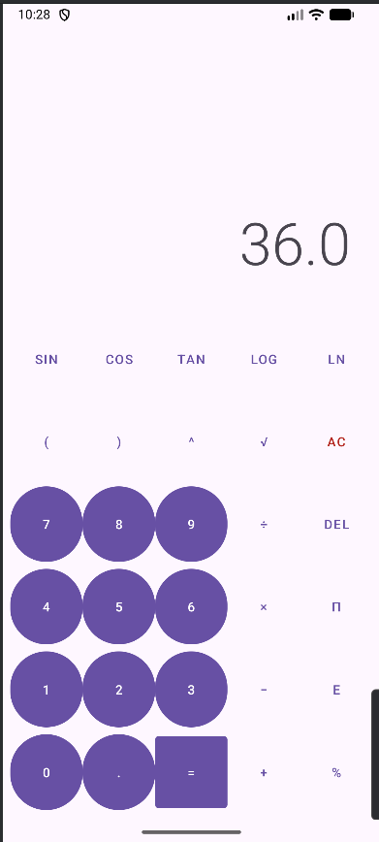
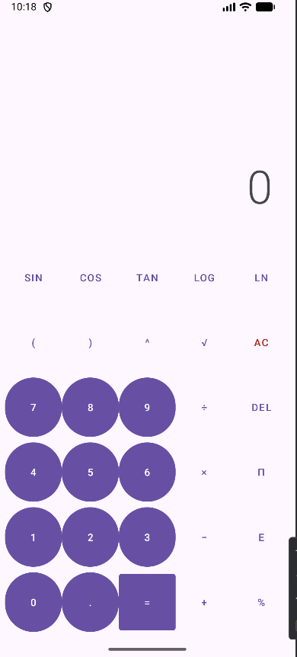

Result:
The scientific calculator application was successfully developed, and it performs arithmetic and scientific calculations correctly with proper display of results.

